About the Author
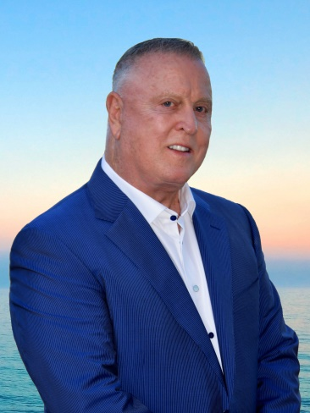
Seeking to make the most of his DASH, Charles G. Irion is a publisher, award-winning author, successful entrepreneur, adventurer, humanitarian, artist, executive producer and even an actor. If he can dream it, then Irion can become it.
Earning Bachelor Degrees in both Biology and Economics from University of California, Santa Barbara and a Masters of Business Administration in International Marketing and Finance from Arizona State University’s Thunderbird School of Global Management, Irion’s background is as diverse as his interests. He received recognition as 1975 Rookie of the Region in pharmaceutical sales for JNJ McNeil Laboratories. In 1979 he moved back to Arizona to open an office for commercial real estate firm, Marcus & Millichap. In 1983, Irion founded his own company, U.S. Park Investments. Today, Irion’s business is a leading owner and management company of numerous manufactured home and RV communities in the United States.
For over 15 years, Irion has been an Executive Board Member and International Assessor for Project C.U.R.E., a charity which delivers donated medical equipment and supplies to over 130 countries, many of which Irion has volunteered in. In 2020, after completing his term as President of the Phoenix Phil-Am Lions Club, Irion received the Melvin Jones Award from the International Lions Foundation. These organizations are a small example of the broad-reaching humanitarian and philanthropic charities that Irion supports. After all the charity work he’s done around the world and at home, Irion truly believes we are One World, One People. TM
Still, he wanted more for his DASH.
Following his passion for the written word, Irion made his dreams a reality, publishing fifteen books — comprised of the Summit Murder Mystery series, the Hell series, a cookbook, and the Murdered By Gods series — all inspired by his own taste for adventure. Even as ONE WORLD goes to press, Irion is working on the next book in the Murdered By Gods series…TIMBUKTU!
As an Actor and an Executive Producer, Charles is proud to have worked on several films. His latest, Max Reload and the Nether Blasters, released in August 2020 to terrific reviews and has gained quite a cult following. His next movie project, Jackie Fontaine, is already in pre-production.
Irion’s zeal for adventure encompasses the full gamut. Traveling all over the world, he never tires of the thrill. Whether it’s scuba diving in faraway waters, skydiving over the desert, white water rafting in South America, a member of a climbing expedition on Mt. Everest (from the Chinese side), summiting Kilimanjaro or high wall mountain rappelling in the Bavarian Alps, Irion is forever searching for the next adrenaline-pumping adventure. His biggest thrill is writing novels that take his readers on journeys full of murder, mystery and heart-racing suspense. For more information on Charles G. Irion and his DASH, please visit:

Website: www.charlesirion.com
Facebook: www.facebook.com/charlesgirion
Twitter: @CharlesIrion
Instagram: @charlesirion
YouTube: Charles Irion
Amazon Author Page: amzn.to/2ikRLhr

